**PROJECT OUTCOMES**

The CT image acquired from the CT machine give two dimension cross sectional of brain. However, the image acquired did not extract the tumor from the image. Thus, the image processing is needed to determine the severity of the tumor depends on the size[4].

**Gaps identified in existing system**

In the existing solution of extraction of brain tumor from CT scan images tumor part is detected from the CT scan of the brain. The proposed solution also do the same thing , inform the user about details of tumor using basic image processing techniques. The methods include noise removal and sharpening of the image along with basic morphological functions, erosion and dilation, to obtain the background. Subtraction of background and its negative from different sets of images results in extracted tumor image. The difference in the proposed solution with existing solution is plotting contour and c-label of the tumor and its boundary which provides us with information related to the tumor that can help in a better visualization in diagnosing cases. This process helps in identifying the size, shape and position of the tumor. It helps the medical staff as well as the patient to understand the seriousness of the tumor with the help of different color-labeling for different levels of elevation

**Proposed solution**

The algorithm is a set of image processing fundamental procedures. A set of noise-removal functions accompanied with morphological operations that result in clear image of tumor after passing through high pass filter is the basic idea behind the proposed algorithm. The set of morphological operations used will decide the clarity and quality of the tumor image. A GUI is created in the MATLAB offering the proposed application of extracting the tumor from selected brain image and its visualization using contour plot. Without having to deal with the code, medical staff can select the CT image and study the extracted tumor along with its boundary from contour and c-label options. The GUI also contains options for zoom-in, zoom-out, data cursor for co-ordinates, and prints the selected image

**Analysis and Design -** System requirements set out what the system should do without specifying how it should be done. The requirement set out in this document is complete and consistent. There are 2 types of user of this software-

* Patient
* Doctor

1. Patient can use the software to see the size of the tumor. Its easy for the laymen to understand the size and position of the tumor.

2. Doctor are using for extracting of tumor from CT scan images of brain and visualization of tumor using contour plot.

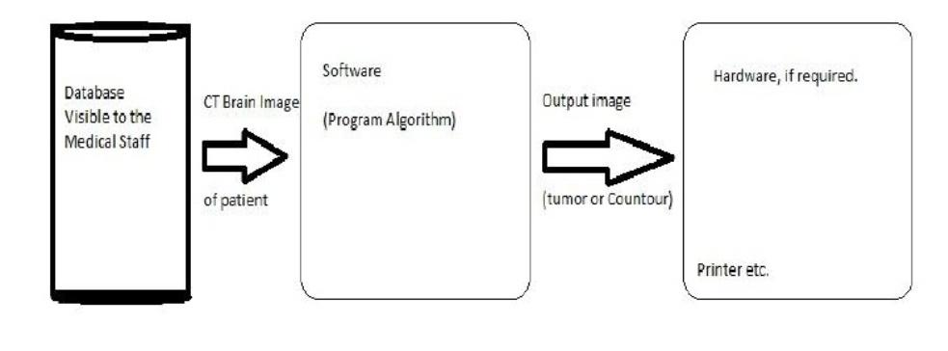The figure of **SYSTEM ARCHITECTURAL DESCRIPTION** is given below:

**METHODOLOGY**

* **Noise Removal and Sharpening**

As a grayscale or colored image maybe the inputted image, the first step is to convert the given image into a grayscale .On procuring the grayscale image, the aim then is to filter it so as to sharpen it and remove any noise, if present. In the algorithm, unsharp filtering of fspecial filter is applied in order to sharpen the image by removing the low intensity values. For noise-removal Gaussian filters is used from fspecial filters.

* **Erosion and Dilation**

After pre-processing, next step is to estimate the background. In order to do so we make use of the basic morphological operations, erosion and dilation. More erosion and less dilation will result in decrease in skull bones image size. To accomplish this we will keep the eroding structural element’s radius bigger than that of dilating structural elements. The structuring element used is diamond.

* **Negation**

The estimated background, obtained by the previous step, will contain the eroded tumor region as our aim was to remove the skull boundary and radius of structuring element was kept as such. Negative of the image can be calculated by subtracting the image from 255 which the highest value any pixel can have.

* **Subtraction**

Subtracting background and negative of background from eroded image will result in images with and without tumors. These images will contain skull’s boundary along with the tumor region and this will be imperfect to use.

* **Contrast adjustment**

In order to provide a clear and well-defined image to work upon, this operation is further applied to the result of subtracting images in previous step. This operation involves increasing the contrast of the filtered image, which is accomplished by performing contrast adjustment techniques. These contrast images will further be subtracted from dilated image.

* **Threshold**

Next step in this algorithm is to calculate global image threshold using Otsu's method, which chooses the threshold to minimize the intra-class variance of the black and white pixels. Thus we will get a clear image of the tumor region.

* **Boundary Detection**

In earlier times without aid of medical imaging tumors were identified manually and boundaries were drawn around it by an expert which always contained issues related to manual-error. Thus, to remove this error, the next step includes producing a clear boundary of the identified tumor using the morphological operation remove, which removes all the interior pixels, thus leaving only the boundary pixels on.

* **Contour and C-label**

Contour is a curve along which the function has a constant value. A contour line (often just called a "contour") joins points of equal elevation (height) above a given level. These different levels are represented by different colored boundaries. Contour-f function gives a better view of the system by each level with different colors. C-label adds height labels to a 2-D Contour plot , providing a better insight to the image.

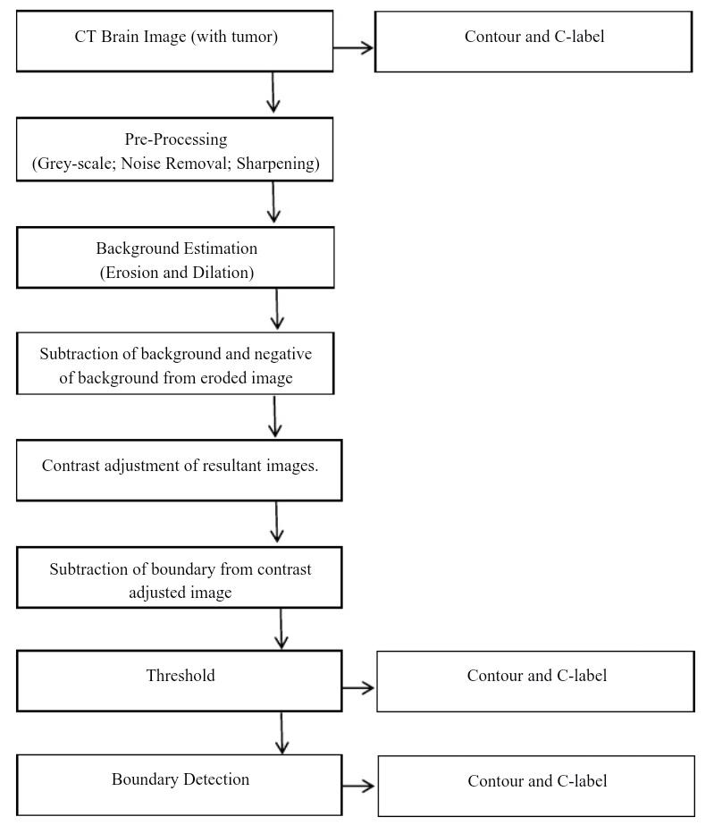The figure shown is **System Interface Description:.**

**Conclusion and Future Enhancements**

The proposed algorithm is inputted with gray scale images of brain that contain tumor/s. The image is processed through various stages of morphological operations like filtering, contra adjustment, erosion, dilation etc. through MATLAB programming. Hence, the tumor is outlined in the original image and clearly demarcated. Contour plot and c-label plot is created to provide 3D visualization from the 2D image. A GUI is also developed which enables the above application with a user friendly interface.

**REFERENCES**

* Gonzalez, “Digital Image Processing”, 2nd ed. Prentice Hall, Year of Publication 2008.
* Rafael C. Gonzalez, Richard E. Woods, Digital Image Processing, Second Edition.
* Rafael C. Gonzalez, Richard E. Woods, Steve L. Eddies, Digital Image Processing Using MATLAB, 2003.
* Rania Hussien Al-Ashwal, Eko Supriyanto, et.al., “Digital Processing for Computed Tomography Images: Brain Tumor Extraction and Histogram Analysis”, Mathematics and Computers in Contemporary Science,
* J. Selvakumar, A. Lakshmi and T. Arivoli, “Brain Tumor Segmentation and its area calculation in Brain MR images using K-means clustering and fuzzy C-mean algorithm”, International Conference on Advances in Engineering, Science and Management, 2012.
* R. Rajeswari, P. Anadhakumar, “Image segmentation and identification of brain tumor using FFT techniques of MRI images”, ACEEE International Journal on Communication, Vol. 02, No. 02, July 2011.
* Mustaqeem, Anam, Ali Javed, and Tehseen Fatima, “An efficient brain tumor detection algorithm using watershed and threshold based segmentation”, International Journal 4, 2012
* P.Dhanalakshmi, T.Kanimozhi, “Automated Segmentation of Brain Tumor using K -Means Clustering and its area calculation”, IJAEEE, 2013
* Q.Hu, G. Quian, A. Aziz, W.L.Nowinski,”Segmentation of Brain from Computed Tomography head images,” Engineering in Medicine and Biology 27th Annual Conference, 2005.
* Natrajan P. , Krishnan N. , Natasha Sandeep kenkre and et.al ,”Tumor Detection using Threshold operation in MRI Brain Images,” IEEE International Conference on Computed Intelligence and Computing Research, 2012.
* P. Natrajan, Debsmita Ghosh, kenkre Natasha Sandeep, Sabiha Jilani, ”Detection of Tumor in Mammogram Images using extended Local Minima Threshold,” International Journal of Engineering and Technology, Vol. 5, No . 3, jun-jul 2013.